

**A201**

**STIJ 3074**

**PROJECT WEB APPLICATION DEVELOPMENT**

**TITLE: HOTEL MANAGEMENT SYSTEM**

**LECTURER: SIR AHMAD HANIS BIN MOHD SHABLI**

**NAME: MUHAMAD IRWAN IHFAN BIN KHALID**

**MATRIC: 263095**

**LINK GITHUB:**

[**https://github.com/muhamadirwan98/stij3074-.git**](https://github.com/muhamadirwan98/stij3074-.git/)  **LINK APP:**

[**irwanihfan.infinityfreeapp.com/Hotel/index.html**](http://irwanihfan.infinityfreeapp.com/hotel/index.html)

**PHP and HTML code**



**SCREENSHOT OF WEB LAYOUT**

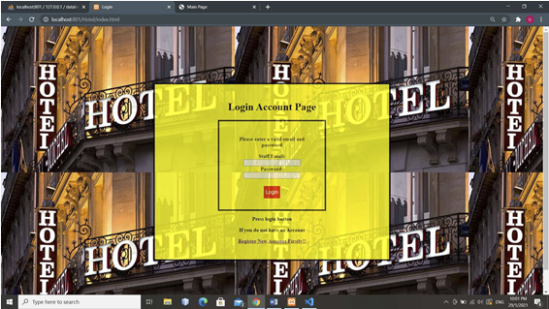

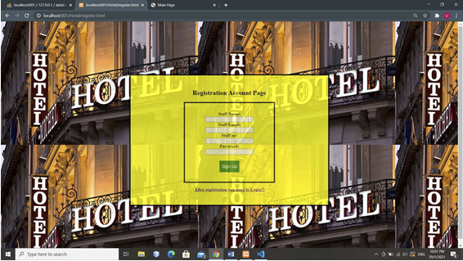

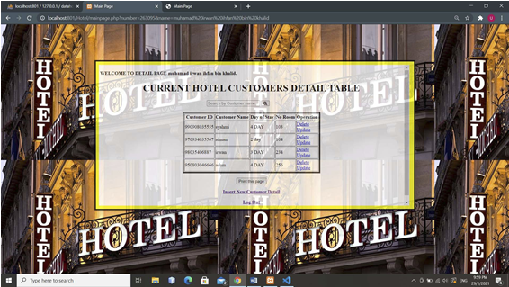

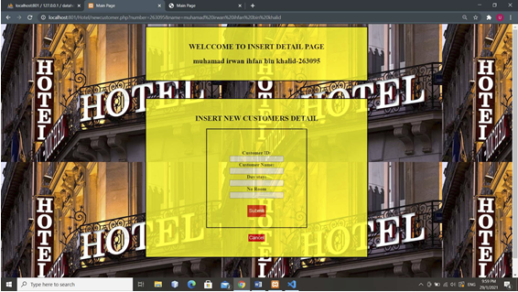

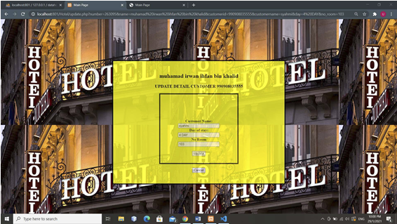

**DATABASE SNAPSHOT**

